# 



Deccan Education Society’s

Brihan Maharashtra College of Commerce, Pune

TY-BBA(CA )

A Project report on

**NutriCount**

By:

* Lavesh Milani (39)
* Nikhil Haswani (26)
* Atharva Shiurkar (04)

Under the guidance of:

**Mrs. Manjusha Wadekar**

NutriCount Project

Presentation

Lavesh Milani (39)

Nikhil Haswani (26)

Atharva Shiurkar (04)

Summary

Objective & Need

What purpose does this project fulfil?

Features

Technical Details

UML Diagrams

**Activity Diagram**

**Sequence Diagram**

**Data Flow Diagram**

**Use Case Diagram**

Project Meeting Log

Screenshots

References

**Summary**

* NutriCount provides the estimation for nutrients required for crops using random forest. Random Forest Regression represents the model with K-Fold Cross Validation technique and the model with acceptable accuracy for the prediction is then obtained
* The algorithm requires input from the user (such as location and cropping). The location is fed to the Weather API which will return certain characteristics (e.g. temperature, humidity, rainfall) and if there is a possibility of heavy rainfall, a precautionary message is displayed to the user, otherwise the proposed algorithm is followed.
* There is a relationship between rainfall intensity and nutrient loss for different fertilizer treatments following each rainfall event. Timely and moderate rainfall can be beneficial to dissolve dry fertilizer and move nutrients into the soil rooting zone, but excessive rain can increase runoff potential and leaching potential of nutrients such as nitrate, sulfate, chloride, and boron.
* Fertilizer use is typically under the limited control of farmers. For the farmers to achieve higher yields and reduce fertilizer loss, competent guidance is required for the best use of these fertilizers. Rainfall that is moderate and falls at the right moment can help nutrients penetrate the soil's rooting zone and dissolve dry fertilizer. However, too much rain can increase the possibility of runoff and the pace at which nutrients like nitrogen (N) which is quintessential, phosphorus (P), and potassium (K) which are crucial, manganese (Mn), and boron (B) that are present in the soil
* The prime objective of “Eco-Fertilization” is to provide useful insight for fertilizer usage by considering short- and long-term weather forecast and reduce environmental pollution by deaccelerating the process of leaching. The application takes multiple input from the user such as crop, area etc. and apply machine learning algorithms to predict the amount and usage of fertilizers.

**Objectives & Need:**

**Objectives:**

* To provide useful information for fertilizer use in terms of nutrients (NPK) by considering weather forecasts.
* To reduce water pollution by slowing down the process of leaching.
* To provide nutrient recommendations using an updated iteration of the random forest algorithm which is based on time-series data to forecast the required quantity of nutrients for various crops by examining rainfall patterns and crop fertility
* To provide nutrient recommendations using an updated iteration of the random forest algorithm which is based on time-series data to forecast the required quantity of nutrients for various crops by examining rainfall patterns and crop fertility.

## Needs:

* Prediction of fertilizer consumption can prevent the toxicity and deficiency in plants to certain extent and this can help farmers to get proper yield without much wastage.
* Eliminate the use of fuzzy logic systems to reduce fertilizer consumption and improve crop productivity.
* It's a difficult task to predict crop yield due to stochastic rain fall pattern and also variation in temperature hence NutriCount will help to prevent confusions and limitations.
* To eliminate Rainfall intensification that may exacerbate leaching losses of reactive N from cropping systems, and that no-till management may buffer against these losses.
* To optimize the fertilizer recommendation method and reduce nitrate residue levels, relationships between crop yield, nitrogen requirement, and nitrate residue level under combined N and P fertilizer application.

**Features :**

1. NutriCount: Provides nutrient estimation for crops using Random Forest Regression model with K-Fold Cross Validation technique.
2. Weather API: Fetches location-based weather characteristics such as temperature, humidity, and rainfall to give precautionary messages in case of heavy rainfall.
3. Relationship between rainfall intensity and nutrient loss: Timely and moderate rainfall can benefit nutrients penetration into soil, but excessive rain can increase nutrient runoff potential.
4. Competent guidance for fertilizer use: Farmers require guidance for the best use of fertilizers to achieve higher yields and reduce fertilizer loss.
5. Objective of Eco-Fertilization: Provide useful insight for fertilizer usage by considering short- and long-term weather forecast and reduce environmental pollution by deaccelerating the process of leaching.
6. Machine learning algorithms: Uses updated iterations of the Random Forest algorithm based on time-series data to forecast the required quantity of nutrients for various crops by examining rainfall patterns and crop fertility.
7. Prediction of fertilizer consumption: Prevents toxicity and deficiency in plants, which helps farmers get proper yield without much wastage.
8. Elimination of fuzzy logic systems: Reduces fertilizer consumption and improves crop productivity.
9. Difficulties in predicting crop yield: NutriCount helps prevent confusions and limitations caused by stochastic rainfall patterns and temperature variations.
10. Optimization of fertilizer recommendation method: Reduces nitrate residue levels and establishes relationships between crop yield, nitrogen requirement, and nitrate residue level under combined N and P fertilizer application.

**What purpose does this project fulfil?**

The "Eco-Fertilization" application fulfils several purposes related to optimizing fertilizer usage for crop cultivation. The application provides useful information for fertilizer use by considering weather forecasts, thus preventing toxicity and deficiency in plants and helping farmers get proper yields without much wastage. The application also eliminates the use of fuzzy logic systems to reduce fertilizer consumption and improve crop productivity. **NutriCount**, a feature of the application, helps prevent confusions and limitations caused by stochastic rainfall patterns and temperature variations. The updated iteration of the Random Forest algorithm, based on time-series data, is used to forecast the required quantity of nutrients for various crops by examining rainfall patterns and crop fertility. The primary objective of the application is to reduce environmental pollution by slowing down the process of leaching, which is achieved by reducing nitrate residue levels and establishing relationships between crop yield, nitrogen requirement, and nitrate residue level under combined N and P fertilizer application. Overall, the "Eco-Fertilization" application aims to optimize the fertilizer recommendation method to benefit crop yield while minimizing environmental impact.

Technical Details:

**Languages:**

Python 3.8.10

JavaScript

HTML

CSS

Jupyter Notebook

**Libraries:**

* Matplotlib 3.4.3

* Flask 2.1.2

* Category Encoders 2.5.0

* requests 2.27.1

* json 2.0.9

* numpy 1.22.3

* pandas 1.3.3

* scikit-learn 1.0.2

**Documentation:**

* ReadTheDocs
* Google Docs

**UML Diagrams:**

Activity Diagram:

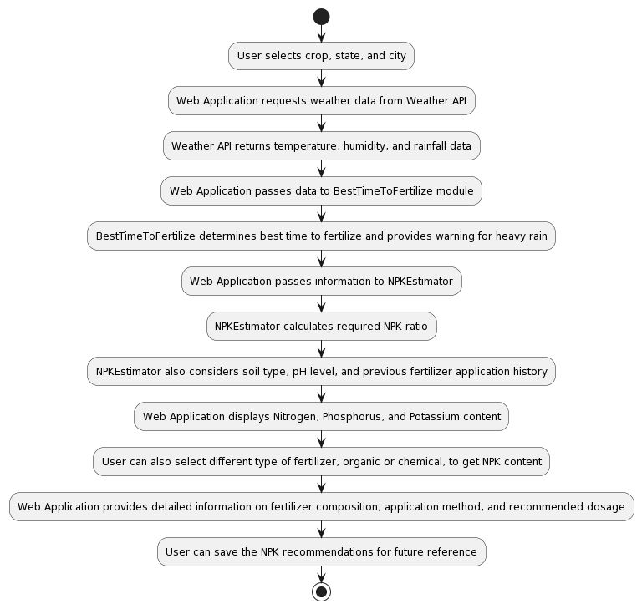

**Sequence Diagram:**

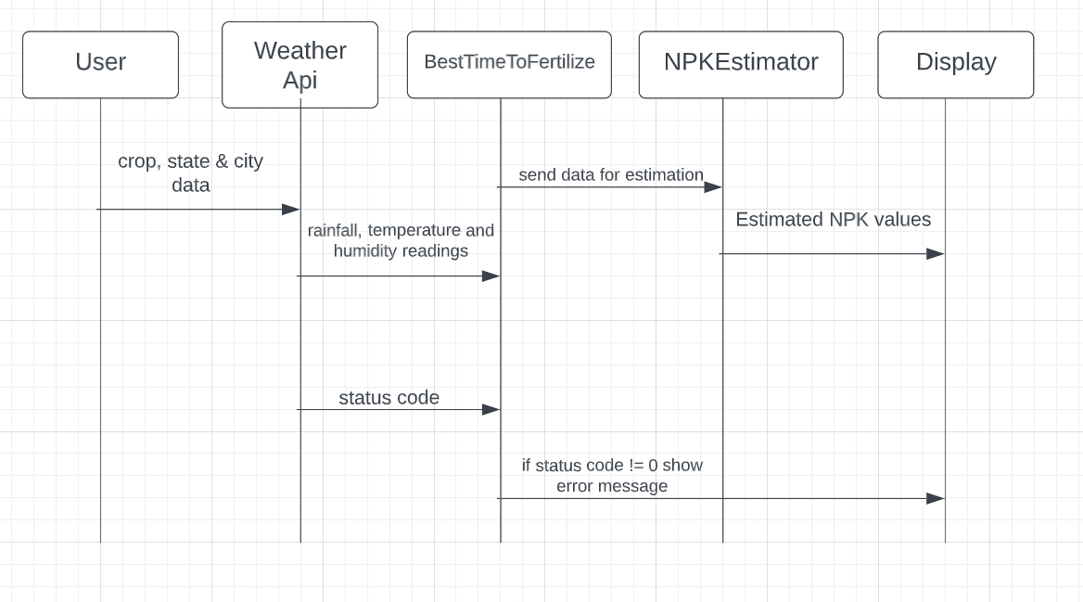

**Use Case:**

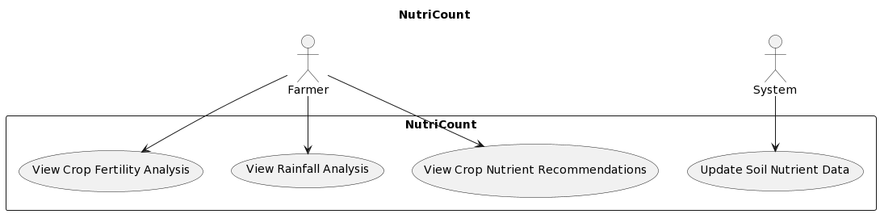

**Project Meeting Log:**

|  |  |  |  |  |
| --- | --- | --- | --- | --- |
| Meeting Date | Lavesh Milani | Nikhil Haswani | Atharva Shiurkar | Topic of Discussion |
| 2022-11-26 | ✅ | ✅ | ✅ | Project Planning. Discussed Technology to be used. Generated a rough roadmap for the next 3 months |
| 2022-11-27 | ✅ | ✅ | ✅ | Deciding Libraries, and Codebase Architecture |
| 2022-12-04 | ✅ | ✅ | ✅ | Working on Backend |
| 2022-12-13 | ✅ | ✅ | ✅ | Working on Backend |
| 2022-12-15 | ✅ | ✅ | ✅ | Follow up on Frontend |
| 2022-12-27 | ✅ | ✅ | ✅ | Datasets Backend |
| 2023-01-02 | ✅ | ✅ | ✅ | API Linking |
| 2023-01-011 | ✅ | ✅ | ✅ | Frontend |
| 2023-01-15 | ✅ | ✅ | ✅ | API Backend |
| 2023-01-22 | ✅ | ✅ | ✅ | Testing and Documentation. |
| 2023-01-29 | ✅ | ✅ | ✅ | Backend |
| 2023-02-05 | ✅ | ✅ | ✅ | UML Diagrams Documentation |
| 2023-02-12 | ✅ | ✅ | ✅ | Documentation |
| 2023-02-19 | ✅ | ✅ | ✅ | Testing and Documentation Review. |
| 2023-02-26 | ✅ | ✅ | ✅ | Generating Project Report |

**Screenshots:**



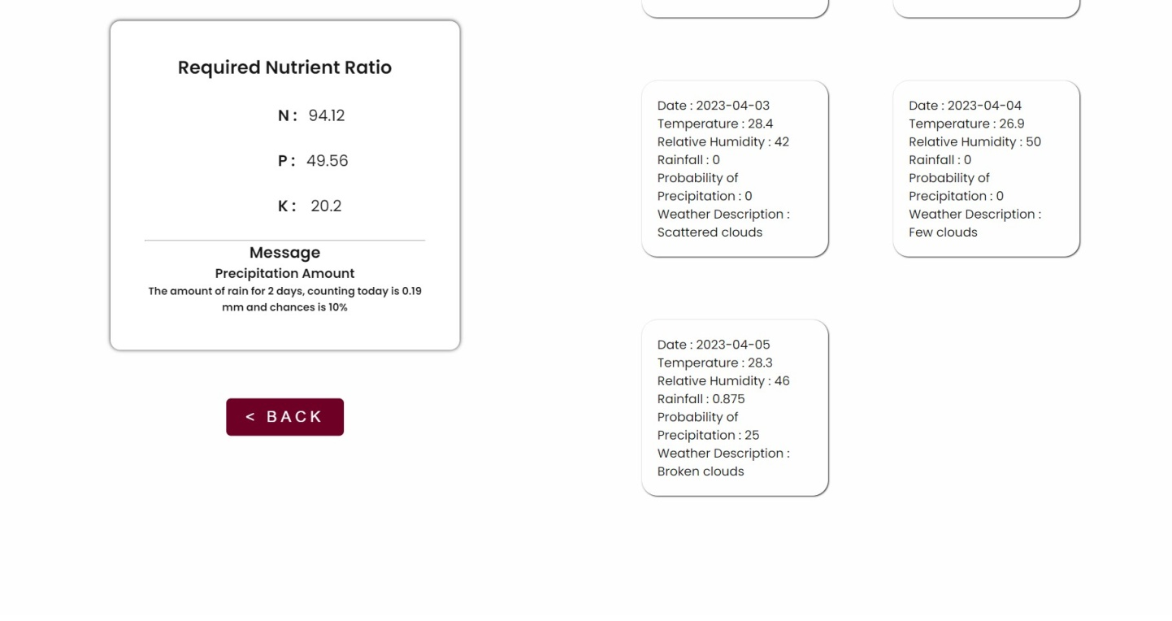

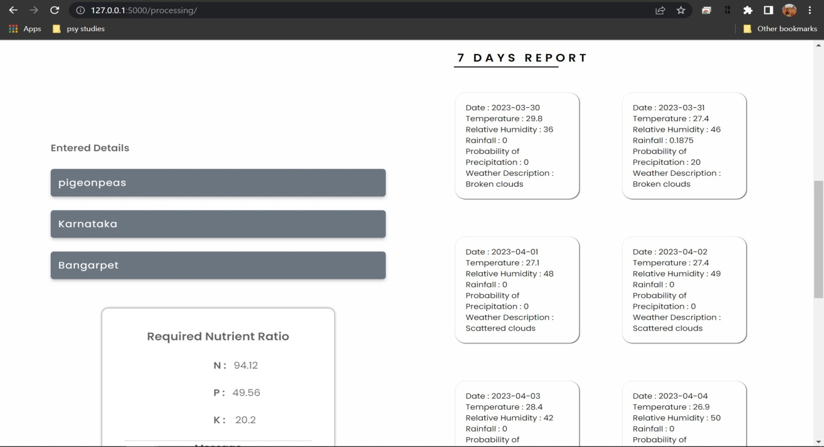

**References:**

[1] Kaggle, “ https://www.kaggle.com/datasets/atharvaingle/crop-recommendation-dataset ”

[2] Krutika Hampannavar, Vijay Bhajantri, Shashikumar G. Totad “Prediction of Crop Fertilizer Consumption,” Fourth International Conference on Computing Communication Control and Automation (ICCUBEA),2018, PP.1-5

[3] G. Prabakaran, D. Vaithiyanathan, Madhavi Ganesa, “Fuzzy decision support system for improving the crop productivity and efficient use of fertilizers,” Computers and Electronics in Agriculture, vol-150, 2018, PP. 88-97

[4] Shital Bhojani, Nirav Bhatt, “Data Mining Techniques for Crop Yield Prediction,” Computers and Electronics in Agriculture, vol-6, 2018, PP. 357-358